MANMOHAN TECHNICAL UNIVERSITY
SCHOOL OF ENGINEERING
DEPARTMENT OF
ELECTRICAL AND ELECTRONICS ENGINEERING
Budhiganga – 4, Morang, Koshi Province, Nepal


“ELEVATOR”
A Third Year Project submitted in partial fulfillment of the requirement for the
Degree of Bachelor in Electrical and Electronics Engineering

Submitted by:

Puspalata Kumari Majhi (SOE/082/BEEE or Exam Roll No.08)
Rajshree Malla Thakuri (SOE/082/BEEE or Exam Roll No.10)
Saurav Chaudhary (SOE/082/BEEE or Roll No.11)
Sushil Dulal (SOE/082/BEEE or Roll No.15)

Submitted to:
Department of Electrical and Electronics Engineering

MANMOHAN TECHNICAL UNIVERSITY
SCHOOL OF ENGINEERING
DEPARTMENT OF
ELECTRICAL AND ELECTRONICS ENGINEERING

The undersigned certify that they have read and recommended to the Manmohan Technical University School of Engineering for acceptance, a final project report entitled “ELEVATOR” submitted by Ms. Puspalata kumari Majhi , Ms. Rajshree Malla Thakuri, Mr. Saurav Chaudhary and Mr. Sushil Dulal. Here in partial fulfillment of the requirements for the degree of Bachelor of Electrical and Electronics Engineering.

…………………………..
(Dr.Ing deepranjan dongol) Supervisor
Full designation
Organization
……………………………..
(Er. )
External Examiner
Full designation Organization

……………………………..
(Er. khemnath khatiwada)
Head of Department
Full designation
Organization.

ACKNOWLEDGEMENT

It is our great fortune that we have got opportunity to carry out this project work under the supervision of Dr.Ing.Deepranjan Dongol on the basis of hardware and lab work and Er.Sagun paudyal on the basis of major project documentation and report in the Department of Electrical and Electronics Engineering ,School of Engineering (SOE), Budhiganga-04 morang,affiliated to Manmohan Technical University(MTU), morang, Nepal.I express my sincere thanks and deepest sense of gratitude to guide for constant support, unparalled guidance and limitless encouragement.

We wish to convey our gratitude to ER Khem Nath Khatiwada ,Co-ordinator, of Department of Electrical and Electronics Engineering, school of Engineering for providing all kinds of infrastructure facility towards the research work.

We would also like to convey our gratitude to all the facility members and staffs of the Department of the Electrical and Electronics Engineering, SOE for their whole heart cooperation to make this work turn into reality,

Team members
Puspalata Kumari Majhi(roll no:08)
Rajshree Malla Thakuri(roll no:10)

Saurav Chaudhary(roll no:11)
Sushil Dulal(roll no 15):

ABSTRACT

This project presents the design and implementation of a microcontroller based elevator control system aimed the achieving safe, reliable and efficient vertical transportation . The system utilizes a microcontroller as the central processing unit to monitor inputs from floor selection buttons, limit switches. Based on the inputs the microcontroller controls the elevator motor, door mechanism and display indicators through appropriate output drivers and circuits.

The proposed system operates using an optimized algorithm that ensure smooth floor to floor movement, accurate stopping, and proper door control. A display is used to indicate the current floor and the direction of travel, while safety features such as overload protection.

Overall, the microcontroller based elevator provides a cost-effective and flexible solution suitable for small to medium scale building. This project describes a simple elevator system controlled by a microcontroller. The microcontroller receives signals from floor buttons and sensors, then controls the motors and doors to move the elevator to the selected floor safely. The system is easy to use, reliable, and more efficient.

In today’s society technology is growing at an exponential rate, and elevator is very common example of technology for consuming time of human being.

Table of contents
ACKNOWLEDGEMENT………………………………………………………………3
ABSRACT………………………………………………………………………………..4
CHAPTER ONE: INTRODUCTION………………………………………………......6
1.1Background……………………………….....................................................................6
1.2concept…………………………………………………………………………………7
1.3 objectives……………………………………………………………………………...7
CHAPTER TWO: LITERATURE REVIEW…………………………………………8
2.1 Segment display……………………………………………………………………….8
2.2 Driver Chip L293D……………………………………………………………………8
2.3 limit Switch……………………………………………………………………………9
2.4: ULN2003……………………………………………………………………………..9
2.5 Push Button ………………………………………………………………………….10
2.6 working Principle…………………………………………………………………….10
CHAPTER THREE: METHODOLOGY………………………………………11
3.1 Project Framework………………………………………………………………..…..11
3.2 Block Diagram………………………………………………………………………..12
3.3 Preliminary design………………………………………………………………...13-14
3.4 flow chart……………………………………………………………………………..15
3.5 Input signal and seven segment display…………………………………………...15-16
3.6 System Design and Modeling………………………………………………………. .17
CHAPTER FOUR:FINAL ANALYSIS AND DESIGN……………………………,,,18
4.1 Result………………………………………………………………………………....18
4.2 Result analysis……………………………………………………………………..18-19
4.4 conclusion…………………………………………………………………20
REFRENCE…………………………………………………………….….21

CHAPTER ONE :INTRODUCTION

  - Background
Elevator are essential system used in buildings to transport people and goods between different floors efficiently and safely. Traditionally, elevator control systems were designed using relay logic, which involved many mechanical switches and wiring. Although functional, relay based systems were bulky, difficult to modify, less reliable, and required frequent maintenance due to wear and tear.

With advancement of electronics and automation technology, microcontrollers have become a popular alternative for controlling elevators. A microcontroller is a compact, programmable device capable of processing inputs, executing logic and controlling outputs. It allows engineers to implement more accurate, flexible, and reliable control systems with fewer components.

Using a microcontroller in elevator systems makes it possible to integrate features such as automatic floor detection, smooth motor control, and a digital floor display. Additionally the system become easier to upgrade or customize by rewiring the entire system.

Thus , the shift from relay based control to microcontroller based design has greatly improved elevator performance, safety, and efficiency while reducing complexity and maintenance costs. This forms the foundation for modern elevator automation system used today.

  - Concept

For this particular elevator system a 3 floor elevator was designed. It consists of ground floor , first floor, second floor. when a user presses a floor button , the microcontroller identifies the request and activates the motor driver to move the elevator up and down.
2nd floor

1st floor

Gnd
floor
lift

Figure 1.1 : Basic concept
1.3 Objectives:

- To design a fully automatic elevator system using a microcontroller.

- To control elevator movement between floors using motor direction control.

- To display the current floor number on a 7 segment display .

- To improve the reliability and efficiency of elevator operation using microcontroller.

CHAPTER TWO : LITERATURE REVIEW

  - 7 Segment Display:
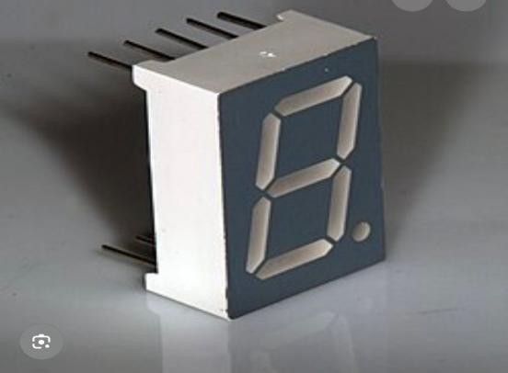
Fig 1.2. 7 segment display
It is designed to provide clear and bright numerical and directional indicators for elevator.

  - 7447 IC :

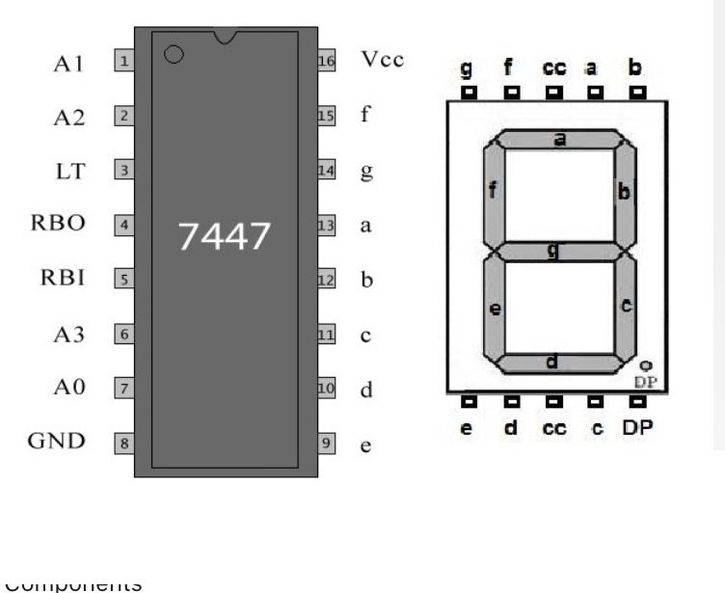

Fig 1.3. 7447 IC

The ic 7447 is a BCD(Binary Coded Decimal) to 7-segment decoder/driver. It takes a 4-bit BCD input and drives a common anode 7 segments display.

  - Limit switch :

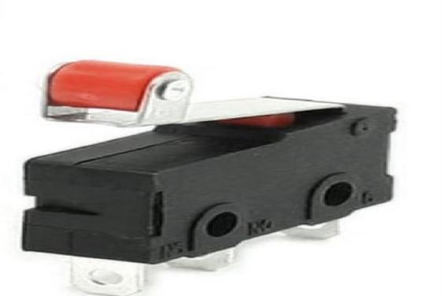

Fig 2 : limit switch

These switches acts as an sensors, monitoring the movement of the elevator cart when signaling. It reaches specific points, such as floor or the end of its travel range.

  - ULN2003 :

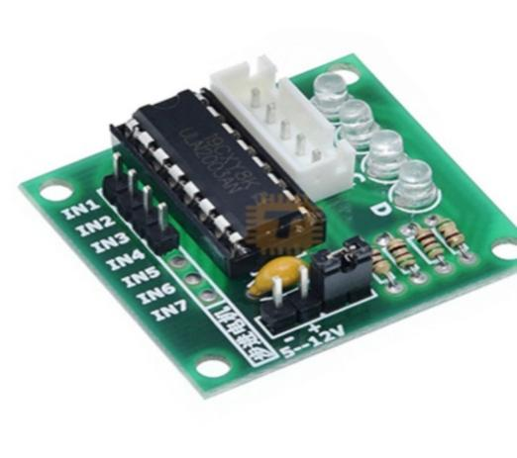
Fig 3 : ULN2003

The ULN2003 is a high voltage , high current Darlington transistor array IC with seven NPN Darlington pairs. It is designed to drive high power loads , relays, stepper motors. The ULN2003 is used to drive the stepper motors .

  - Push button switch :

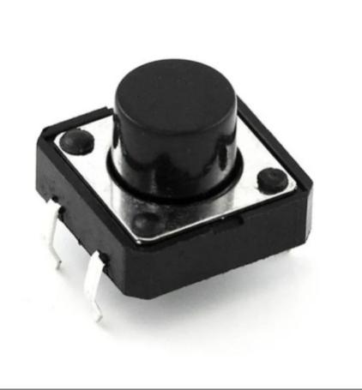

Fig 4: push button switch

To design push button switch system for an elevator using an 8051 microcontroller, we need to interface push buttons (for floor selection),control the elevator motor, and manage the logic for floor navigation.

  - Buffer circuit
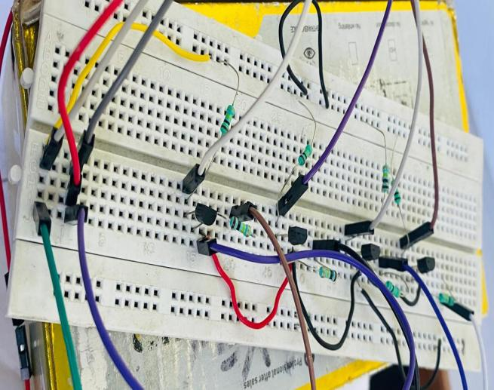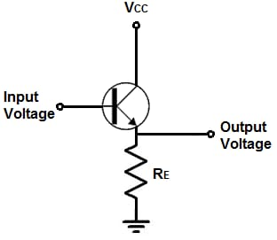
Figure 5: Buffer circuit

A buffer circuit is an electronic stage placed between a signal and source and a load ( like motor driver). The role of buffer circuit in elevator using microcontroller is current amplification.

CHAPTER THREE: METHODOLOGY

3.1. Project framework
Selection of project

Study of the project

Software simulation

Collection of components

Hardware implementation

Testing and feedbacks

Final product

Figure 6 : Project Framework
The project framework covers the chronological activities of the project. In the beginning, team has selectedtopic on major project and elevtor using microcontroller has got final on proposal. study materials and information are gathered to study different methods of construction.NI multisim is used for software simulation. After successfully done in software we gather the component and start implementation in hardware. Many steps of testing are engaged to implement the hardware design. All components of controller circuit are assemble and tested regularly. At last the product is presented in electronic lab and satisfactory result .

3.2 Block Diagram

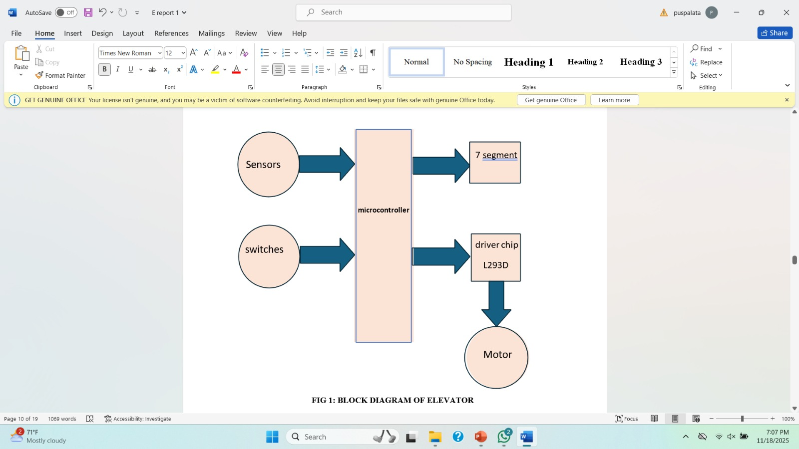

Figure 7 : Block Diagram
The block diagram shows the operation mechanism used in elevator.In this elevator system, the input section consists of sensors and switch signals that provide essential information to the microcontroller. The sensors detect the position of the elevator cabin, such as when the lift reaches each floor or when it touches the limit points. Similarly, switches represent the call buttons pressed by users either inside the cabin or on different floors. These inputs are fed into the microcontroller, which acts as the central processing unit of the system. The microcontroller reads these input signals, decides the direction of movement, and manages the operation of the elevator based on the programmed logic. It then sends output signals to two main components: the 7-segment display and the motor driver (L293D). The 7-segment display shows the current floor number to the user, while the L293D driver amplifies the microcontroller’s signal to operate the elevator motor. The motor receives direction and speed control commands through the driver, allowing the elevator to move up or down smoothly. In this way, the microcontroller processes all input information and controls the output devices to ensure proper movement and display of the elevator system.

3.3 Perliminary Design

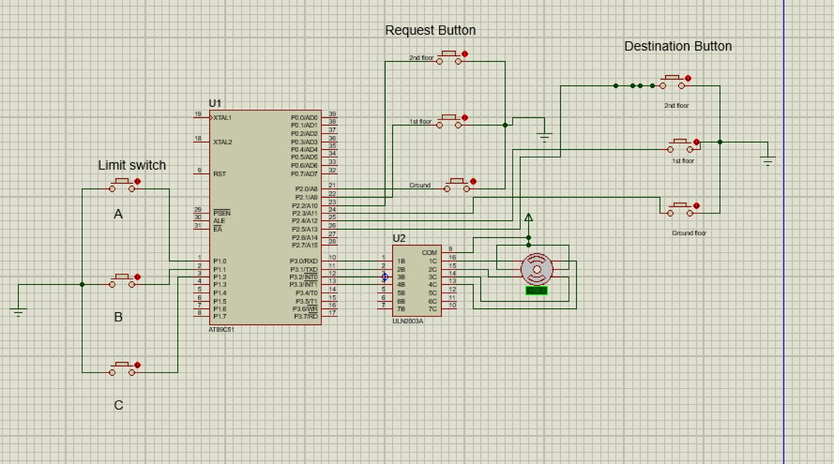
Figure 8: Perliminary design.

The elevator operates in a closed-loop control system, where the microcontroller continuously monitors inputs and adjusts outputs based on the programmed algorithm. The workflow is as follows:
a. Initialization
.- The elevator is set to a default state (e.g., ground floor, door closed).
- The microcontroller checks sensor status to confirm the elevator's position.
b. Input Processing
- Floor Selection: When a user presses a button (inside the elevator or on a floor), the signal is sent to the microcontroller's input pins (e.g., Port 1).

c. Control Logic
- The microcontroller processes inputs using a program written in Assembly or C, stored in its ROM.
- Movement Control:
- If a higher floor is selected, the microcontroller sends a signal to the motor driver (via Port 2, for example) to rotate the motor in the "up" direction.
- For a lower floor, it signals the motor to move "down."
- The motor stops when the position sensor indicates the target floor.
- Limit switches prevent the elevator from moving beyond the top/bottom floors.

3.4 flow chart :

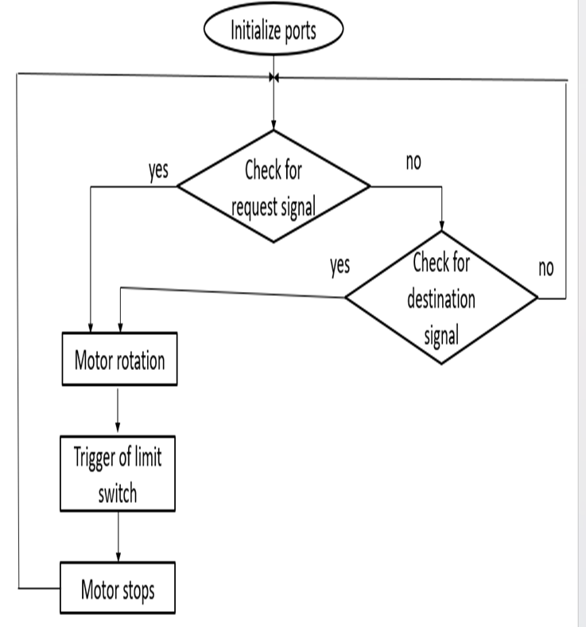

Figure 9: flow chart
3.5 Input signal and seven segment display :
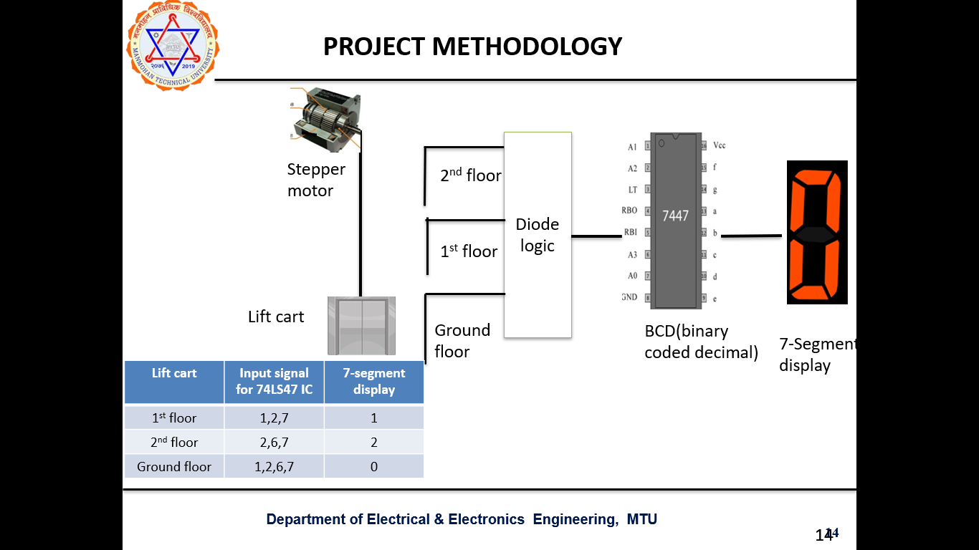 Figure : lift in ground floor displaying 0
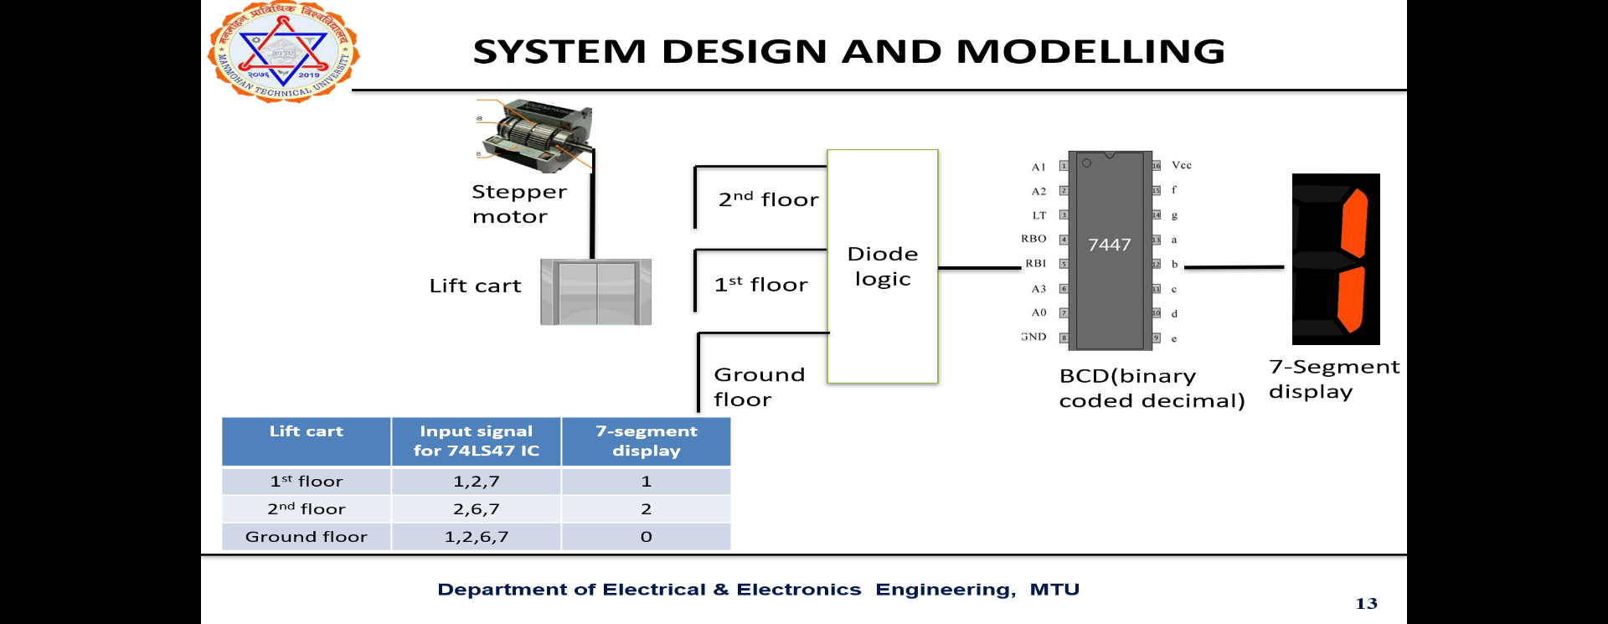
Figure : lift in first floor displaying 1
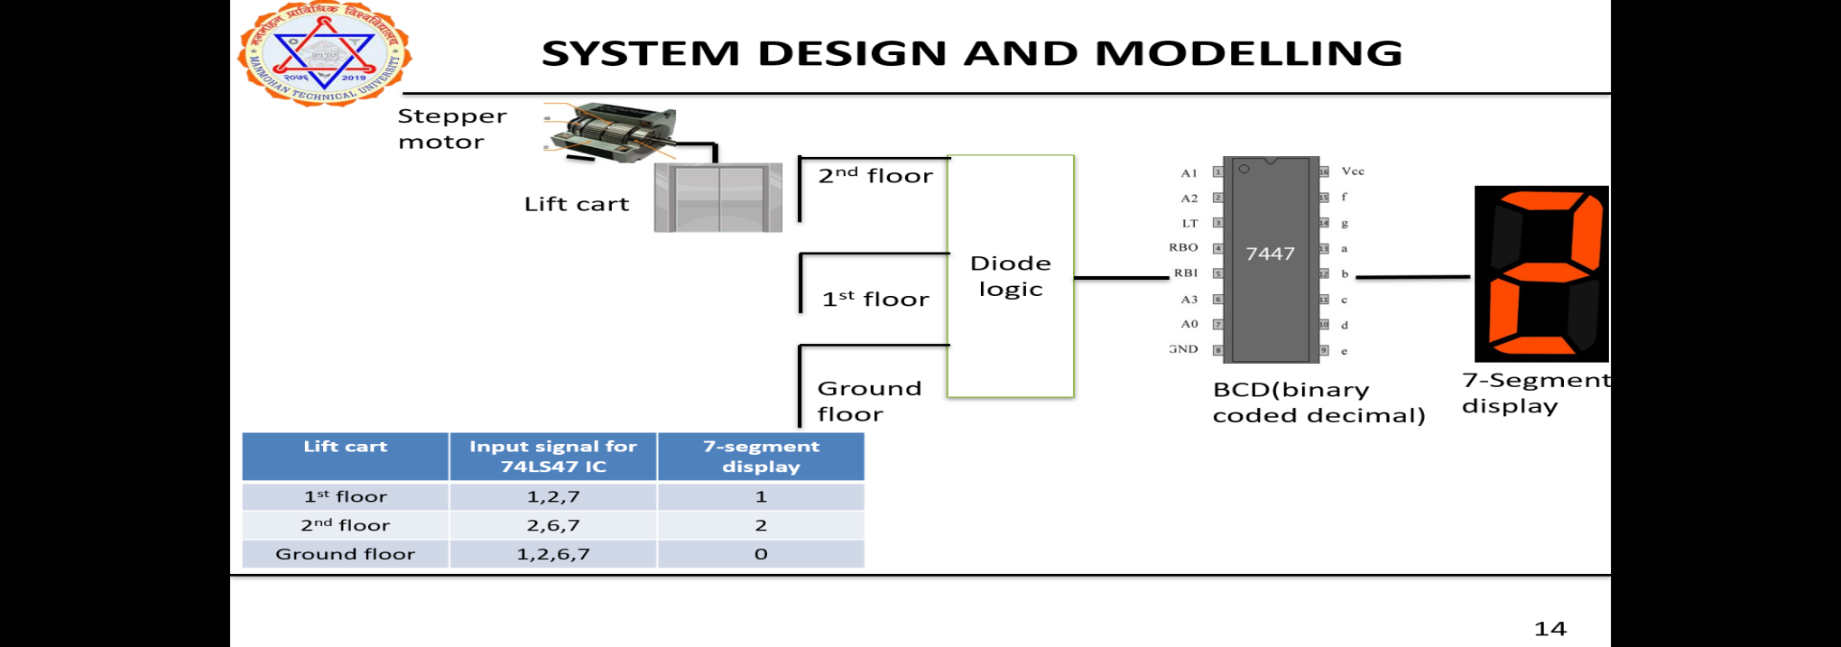
Figure: lift in 2nd floor displaying 2

3.5 SYSTEM DESIGN AND MODELING

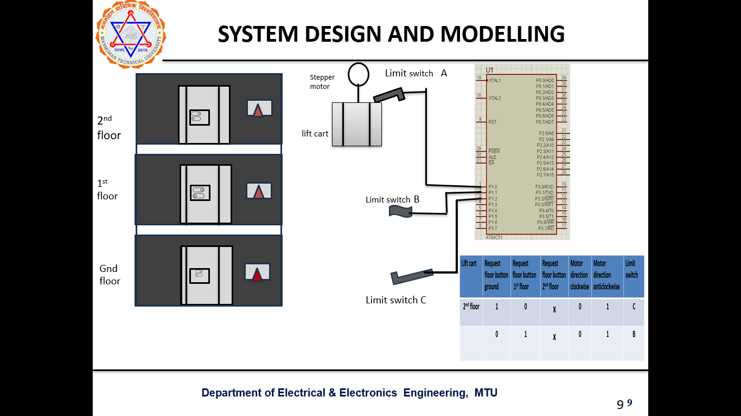
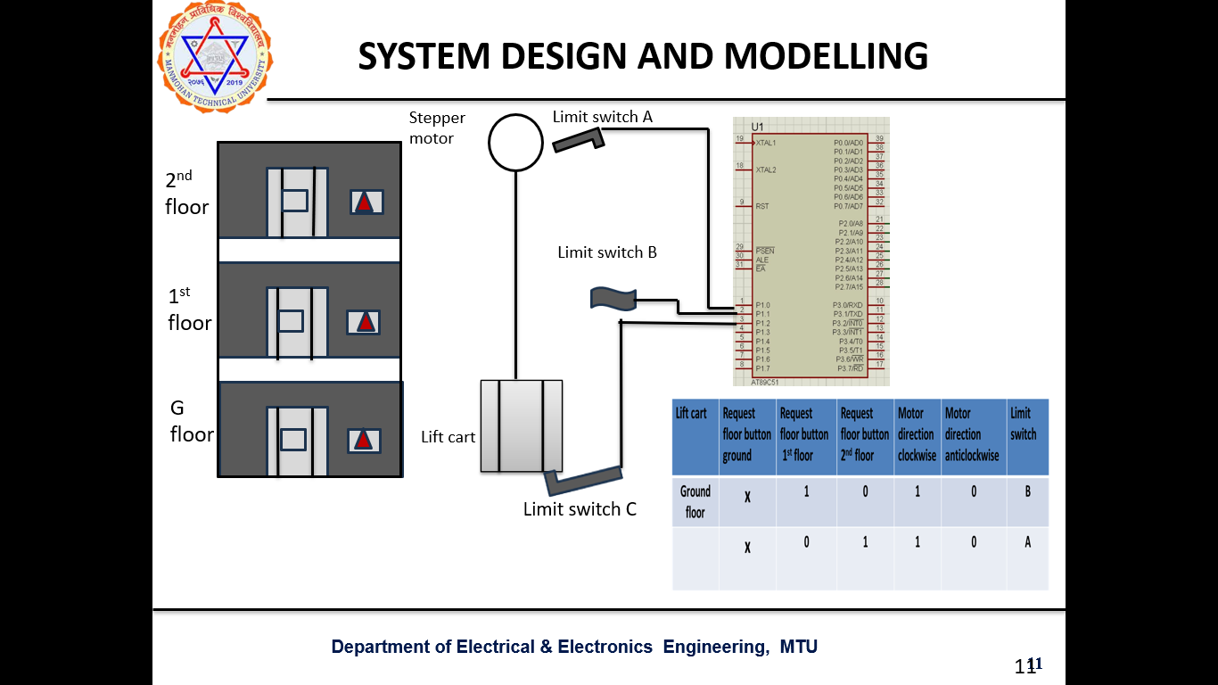
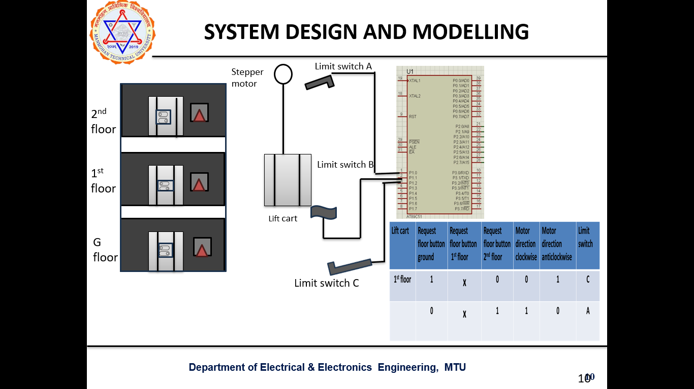
CHAPTER FOUR: FINAL ANALYSIS AND DESIGN

4.1 RESULT
The elevator control system using a microcontroller was successfully designed and implemented. The programmed microcontroller correctly received input signals from push buttons, limit switches, and sensors, and provided accurate output signals to the motor driver for controlling the elevator movement. The elevator prototype operated smoothly between floors, stopping at the correct positions. Safety features such as limit switch activation and overload indication also worked properly. Overall, the system demonstrated reliable, efficient, and automatic control of elevator operations using embedded technology.

4.2 RESULT ANALYSIS

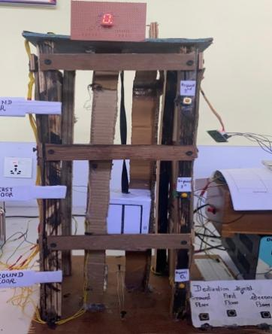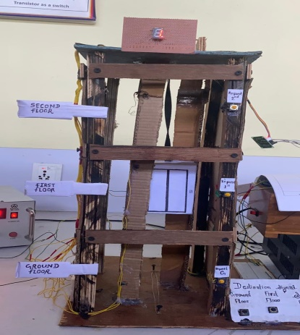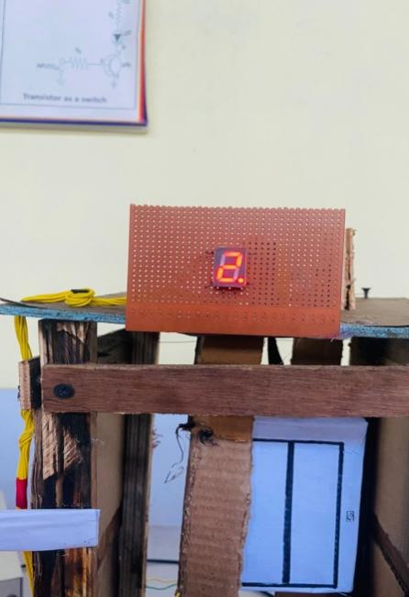
Figure 10: Display of current floor of the lift and final product
The elevator system developed using a microcontroller showed efficient and accurate performance in all tested condition. The input components such as floors selection switches, limit switch. The system responded quickly to user commands, with minimal delay between button press and motor activation. Limit switch successfully prevented over travel, providing safety. Motor operation was stable, and the cabin stopped at the designated floors. During repeated testing , no major faults were observed. Minor fluctuations in motor speed occurred under varying loads. Overall, the analysis confirms that the microcontroller based elevator system is reliable, economical, and suitable for small scale automated lifting application.

4.3 CONCLUSION:

The elevator system using a microcontroller was successfully designed and implemented, demonstrating reliable, safe, and automatic control of elevator operations. The microcontroller efficiently processed inputs from floor buttons , sensor and limit switches and generated accurate output signals to drive the motor and control the elevator movement. The system showed smooth operation and safety mechanism.
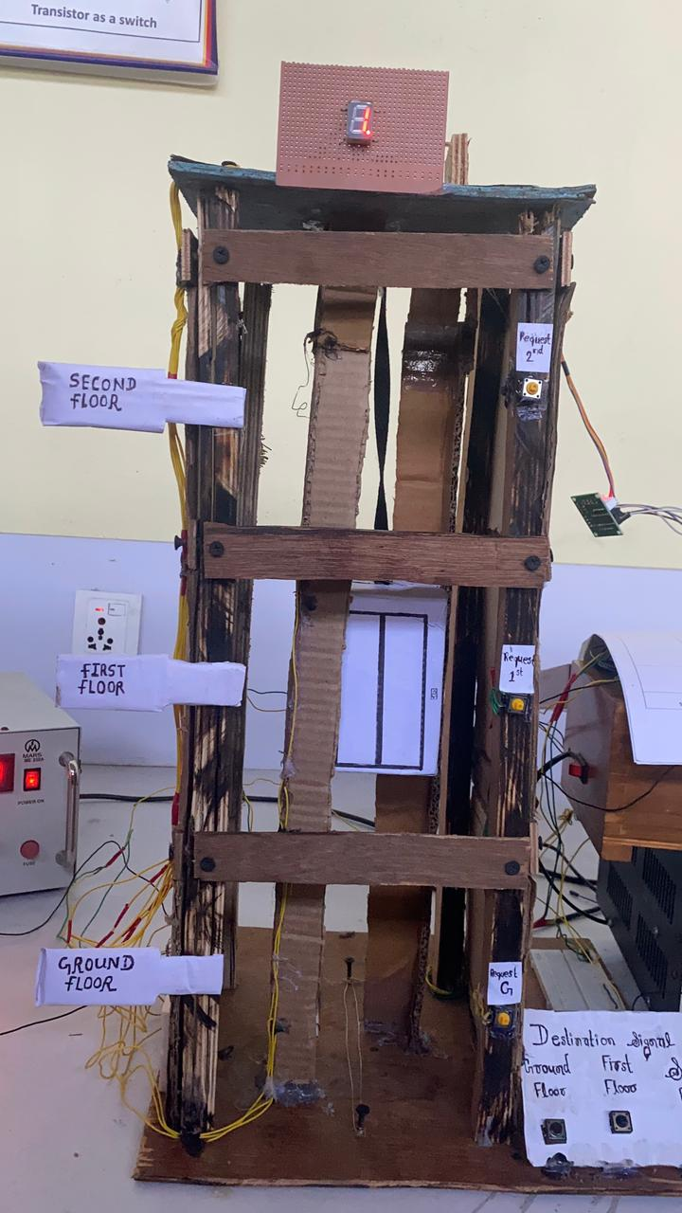
Figure 13: final product

Reference:

https://www.electronicsforu.com/electronics-projects/elevator-control-system-8051

https://circuitdigest.com/microcontroller-projects/interfacing-dc-motor-with-8051

https://nevonprojects.com/elevator-control-system-using-8051/
https://www.electroschematics.com/8051-elevator-project/

